Testing and Documentation

**Technologies Used** – ASP.NET, MVC, C#, ADO.NET, Windows Forms, LINQ, Entity Framework, Web API, Postman, MS SQL Server

Install Visual Studio 2019/2022 , SQL Management Studio, Postman Tool.

**ASP.NET MVC Web Interface:**

Created Employee Management System design using ASP.NET, created database and tables. Performed create, read, update or edit and delete the employee records.

Enter the employee details in the web application

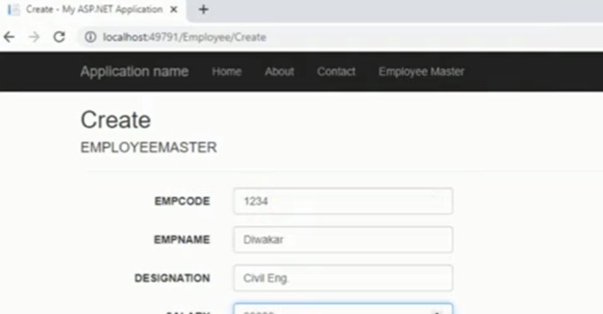

Editing the employee details

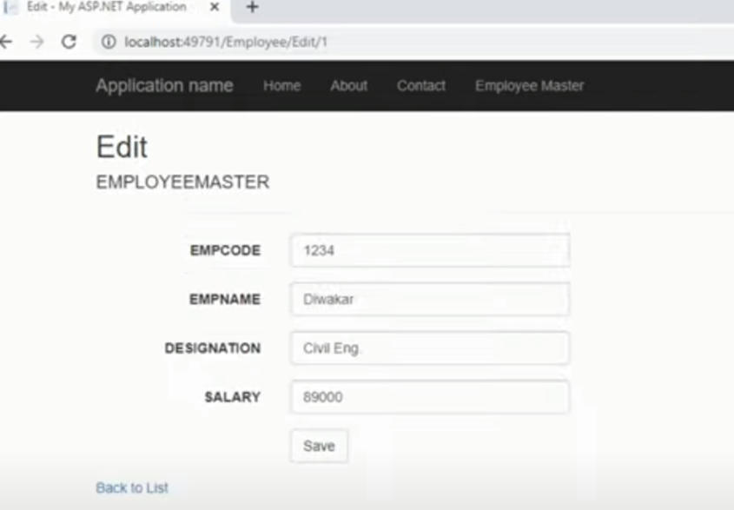

The list of employee details, after creation and editing the employee details

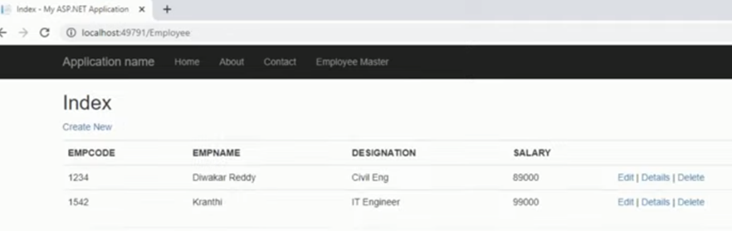

Deleting the selective employee details

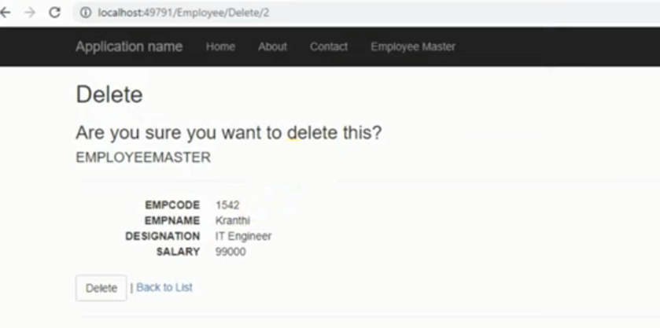

**Windows Forms Desktop Interface:**

Created Employee Management System design using Windows Forms with C#, ADO.NET and MS SQL Server. Created database and tables. Performed adding, editing, and deleting the employee records in this setup.

Adding the employee details in the database

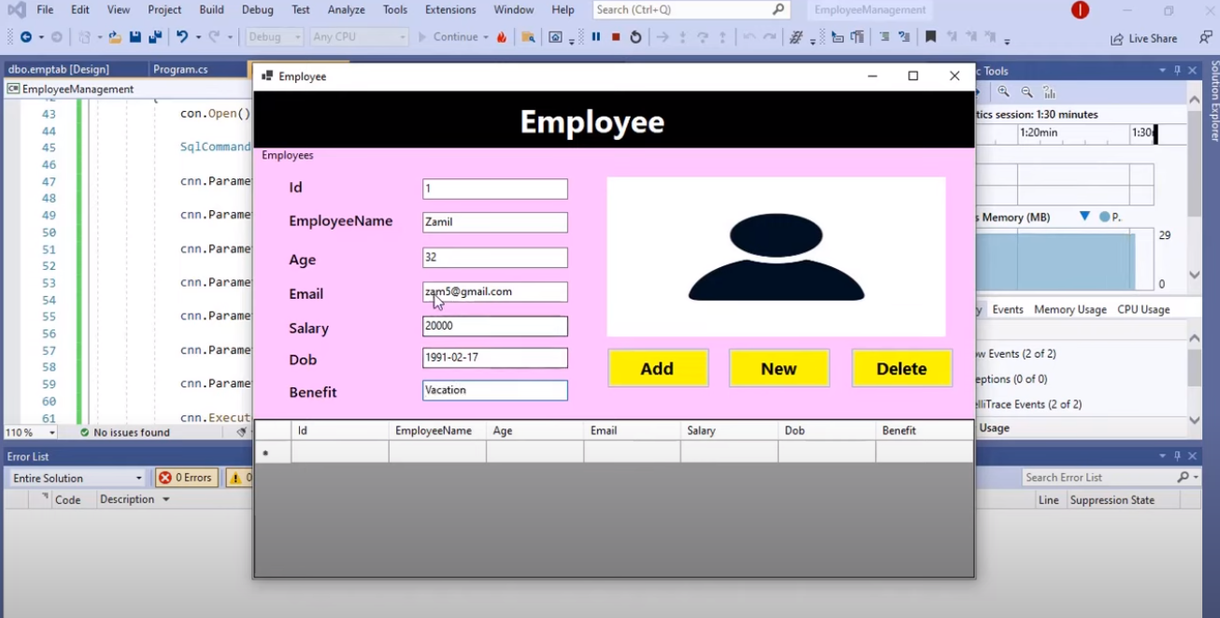

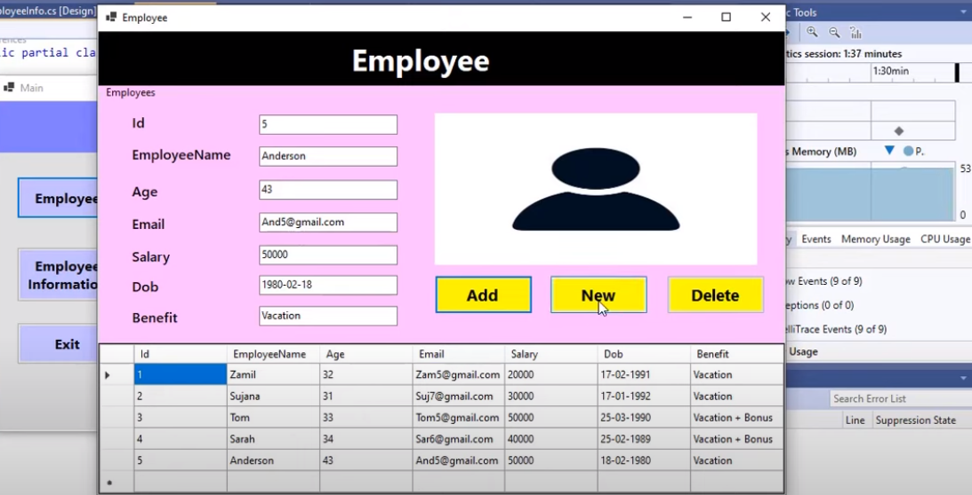

Deleting the employee details by selecting particular row and view the employee details in information screen.

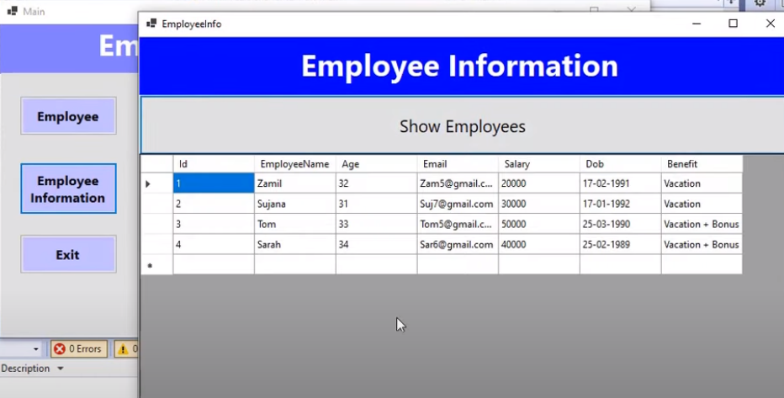

**WEB API:**

Develop a Web API to expose employee details and retrieving the records through endpoints and test using postman tool

